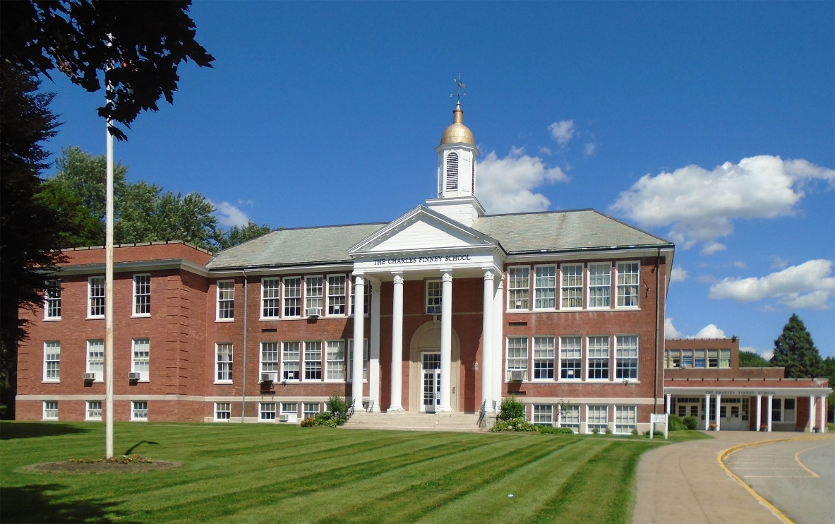

MINIMUM CAPACITY :-

The Minumum intake capacity

of students is between 300-620

children

LIBRARY :-

The Libarary is Available.

CANTEEN:-

The Canteen Facility is Available.

BOARDING :-

No availablility of boarding.

SPORTS :-

There are different categories

sports available.

Girls Volleyball

Boys Volleyball

Football

|  |  |  |
| --- | --- | --- |
| THE CHARLES FINNEY SCHOOL ROCHESTER - SCHOOL |  |  |
|  |  |  |
| School Detail :- The Charles Finney School is a private, non-denominational Christian school offering a college preparatory program to students from Pre-Kindergarten through Grade 12. The school has developed a reputation for both student outreach and as a strong competitor, despite its small size.  The Charles Finney School. Logos and other trademarks within this site are the property of their respective owners. No endorsement has been given nor is implied. Payments are free with a [linked bank account.](https://www.doxo.com/) Other payments may have a fee, which will be clearly displayed before checkout. Learn [about doxo](https://www.doxo.com/#peace-of-mind)and how we [protect users' payments.](https://www.doxo.com/about/fraud-scam-prevention/) |  |
|